Revision History
Date | Version | Description | Author
25.03.2014 | 0.1 | First Version of SDD | Alp Kaan Erer, Can Şahin, Burcu Başak Sarıkaya, Fırat Emre Met, Eray Tunçer
01.04.2014 | 0.2 | Final Version of SDD | Alp Kaan Erer, Can Şahin, Burcu Başak Sarıkaya, Fırat Emre Met, Eray Tunçer

TABLE OF CONTENTS
Revision History 1
1 Introduction 3
1.1 References 3
1.1.1 Project References 3
2 Software Architecture overview 3
3 Software design description 4
3.1 Component 1 5
3.1.1 Component interfaces 5
3.1.2 Component design description 5
3.1.3 Workflows and algorithms 5
3.1.4 Software requirements mapping 5
3.2 Component 2 5
3.2.1 Component interfaces 5
3.2.2 Component design description 6
3.2.3 Workflows and algorithms 6
3.2.4 Software requirements mapping 7
3.3 Component 3 7
3.3.1 Component interfaces 7
3.3.2 Component design description 7
3.3.3 Workflows and algorithms 7
3.3.4 Software requirements mapping 8
3.4 Component 4 8
3.4.1 Component interfaces 8
3.4.2 Component design description 8
3.4.3 Workflows and algorithms 9
3.4.4 Software requirements mapping 9
3.5 Component 5 9
3.5.1 Component interfaces 9
3.5.2 Component design description 10
3.5.3 Workflows and algorithms 11
3.5.4 Software requirements mapping 11
4 COTS Identification 11

Introduction

This document describes the design of the BlockBreaker game.

References

Project References

# | Document Identifier | Document Title
DOC 2 | SRS | Software Requirements Specifications

Software Architecture overview

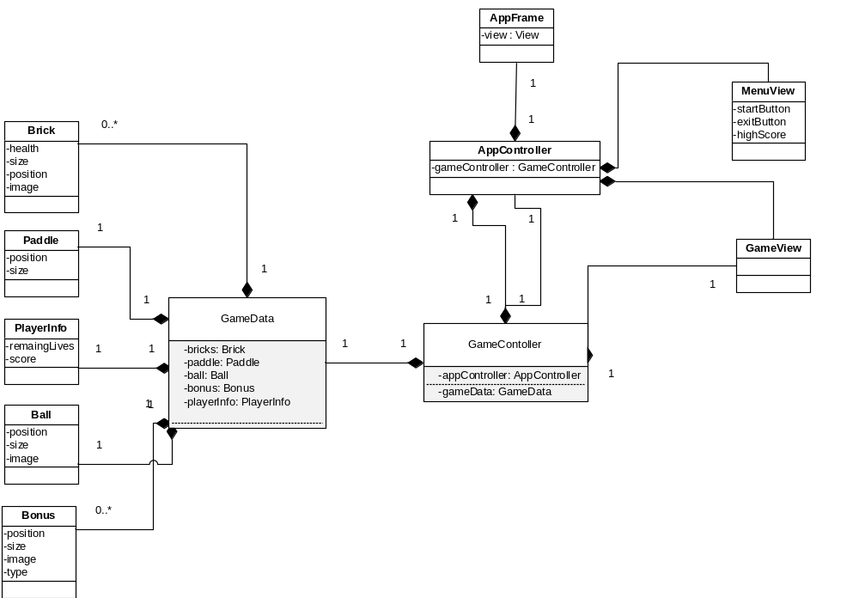

Software design description

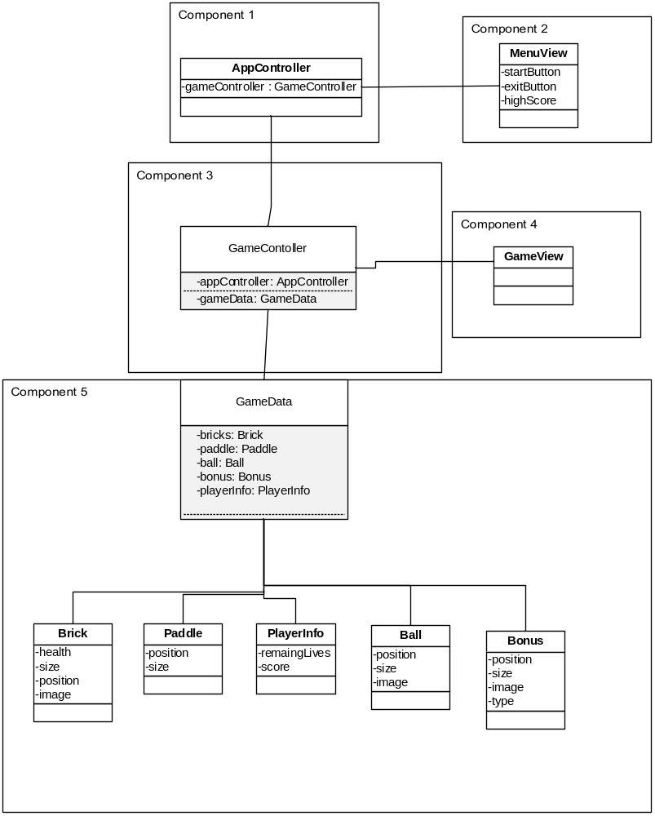

Component 1
AppController

Component interfaces
AppContoller class communicates with the MenuView class with “setHighestScore()” method, also communicates with GameController with “startGame()” method

Component design description
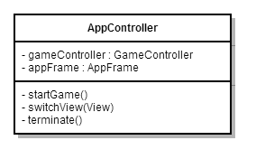

Workflows and algorithms
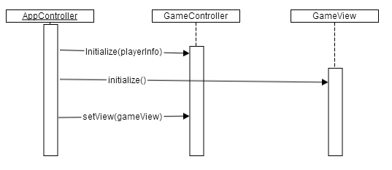

Software requirements mapping
N/A

Component 2
MenuView

Component interfaces
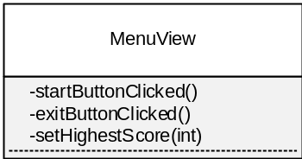

Component design description
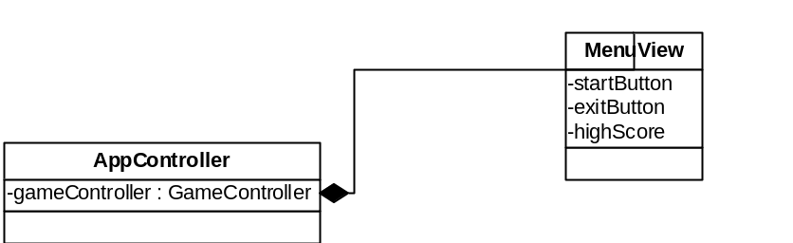

Workflows and algorithms
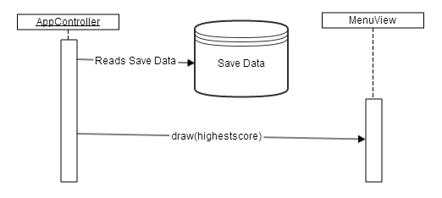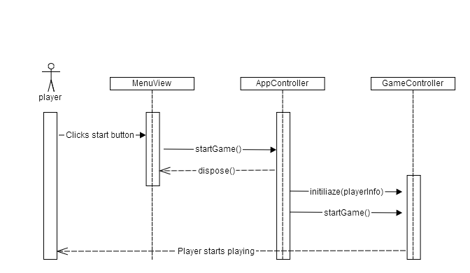
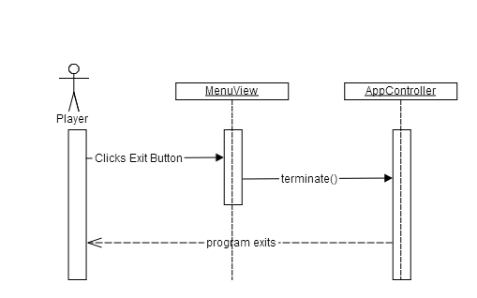

Software requirements mapping
- SRS-BlockBreaker-001
- SRS-BlockBreaker-002
- SRS-BlockBreaker-003

Component 3
GameController

Component interfaces
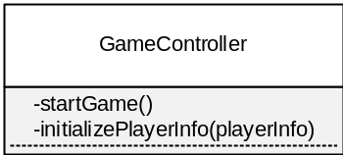

Component design description

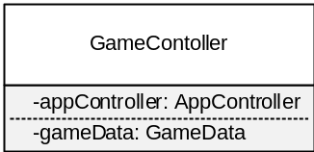

Workflows and algorithms

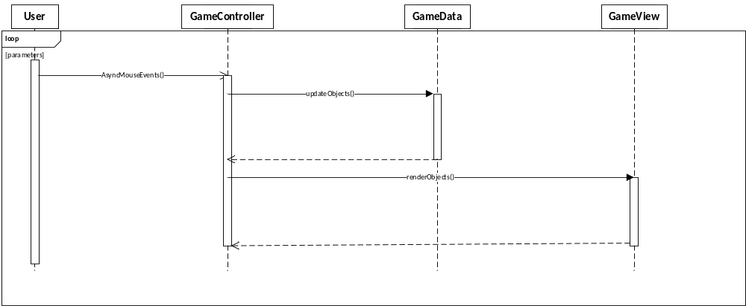

Software requirements mapping
- SRS-BlockBreaker-004
- SRS-BlockBreaker-005
- SRS-BlockBreaker-006
- SRS-BlockBreaker-007

Component 4
GameView

Component interfaces

AppController initialize the GameView with the initialize() method. GameController also updates the User Interface with the renderObjects() method.
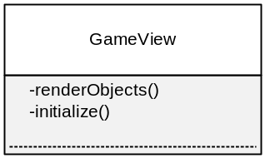

Component design description
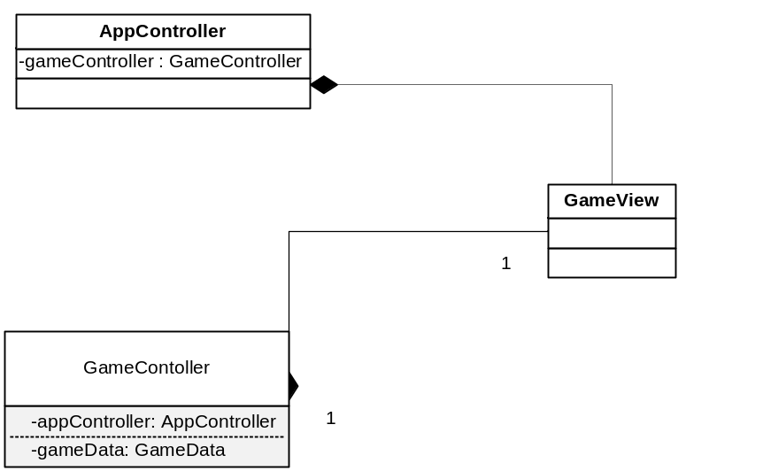

Workflows and algorithms
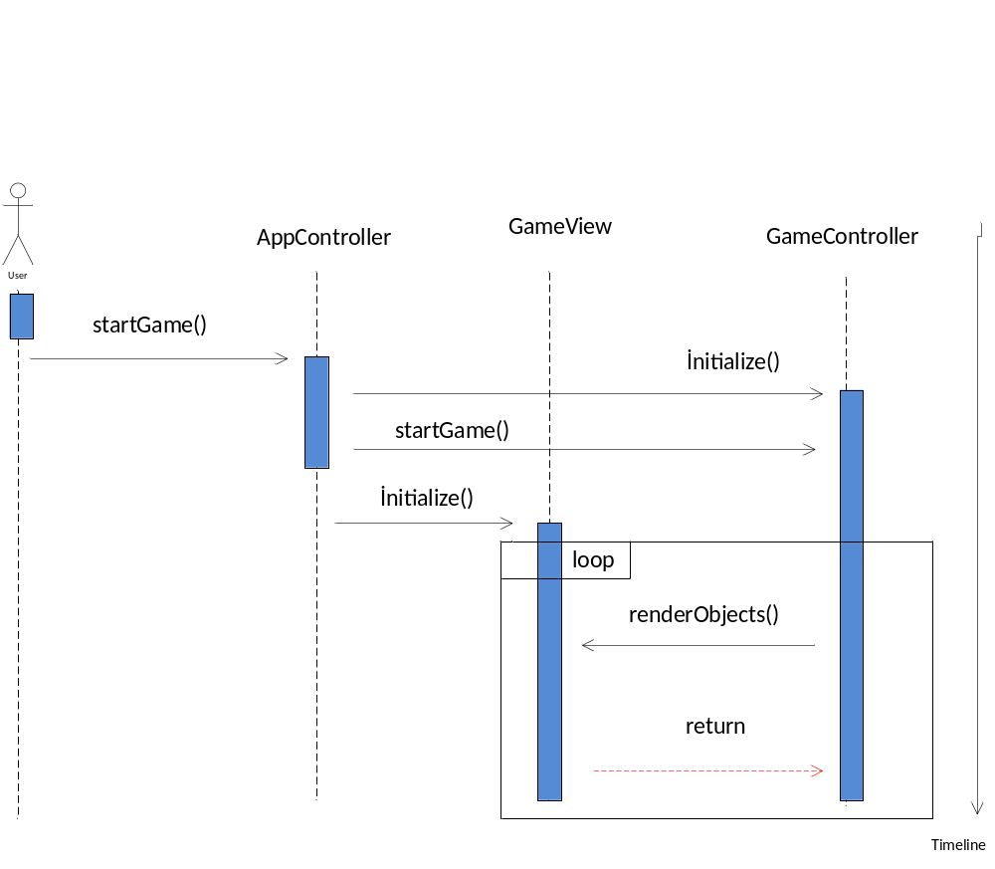

Software requirements mapping
N/A

Component 5
GameData

Component interfaces
GameData will reach Brick, Paddle, Ball, Bonus, PlayerInfo Class’s get() and set() methods. It also communicates GameController Class with get() and set() methods.

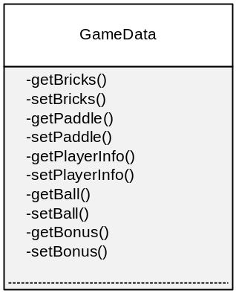

Component design description
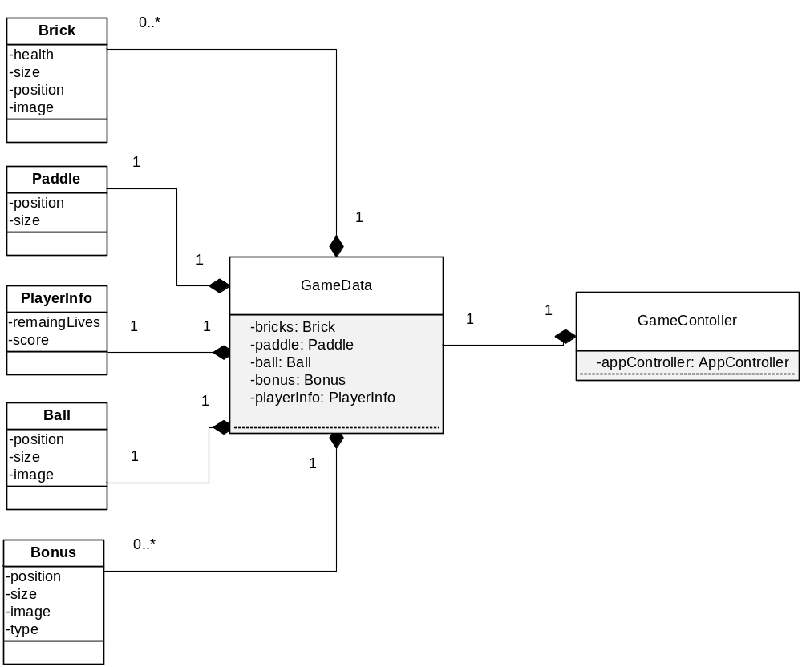

Workflows and algorithms
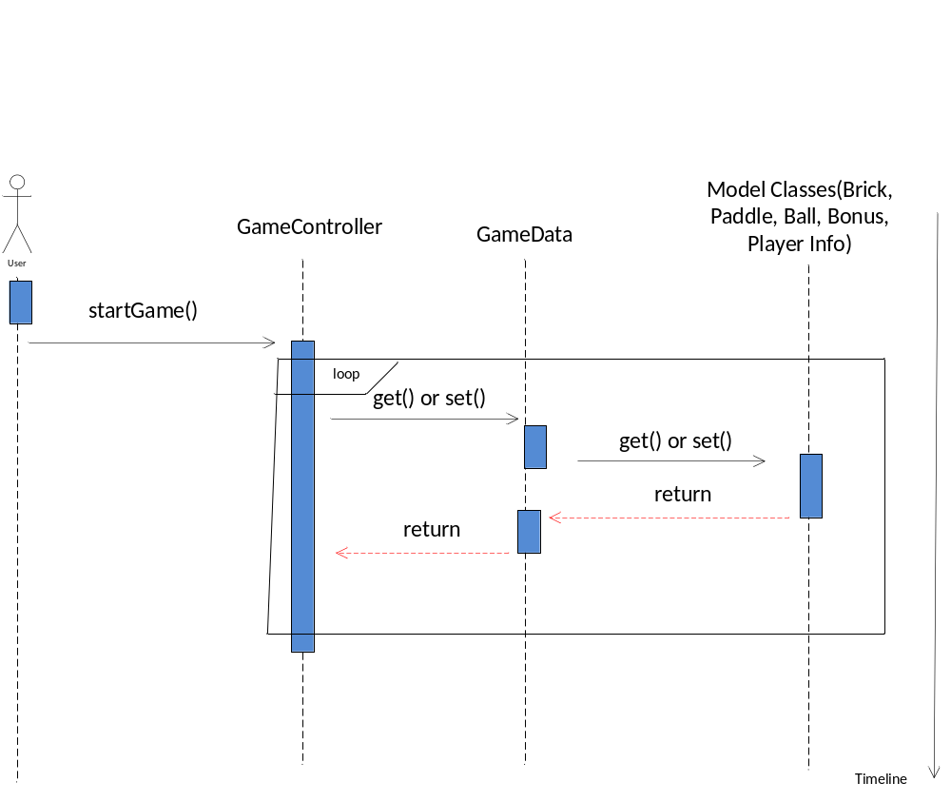

Software requirements mapping
N/A

COTS Identification
N/A

